1. Create one IAM user and assign ec2,s3 full access role.

* first mosly you need to create user test-user and mainly give the password

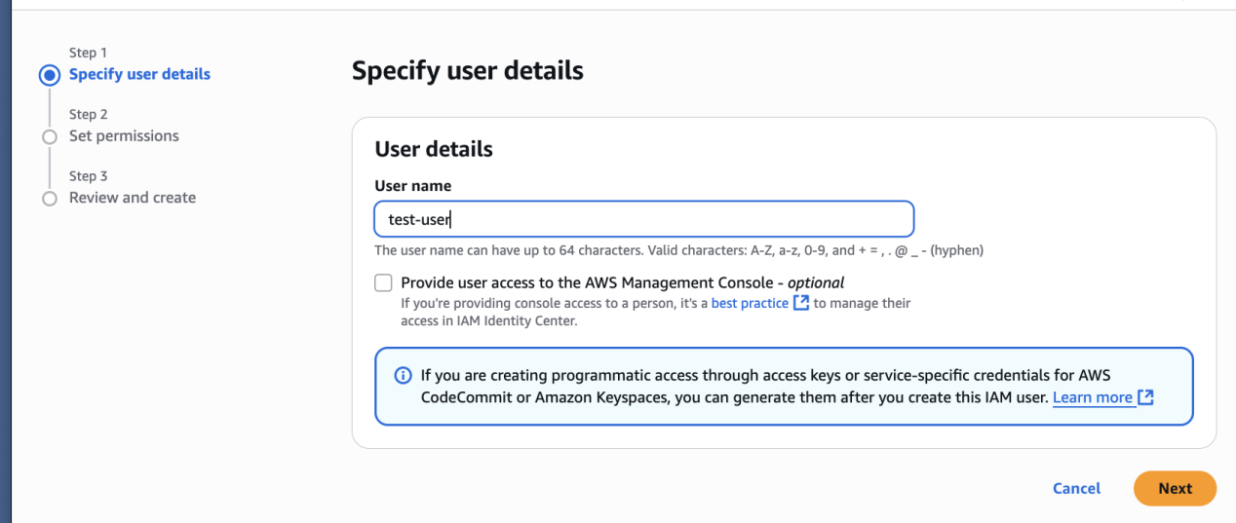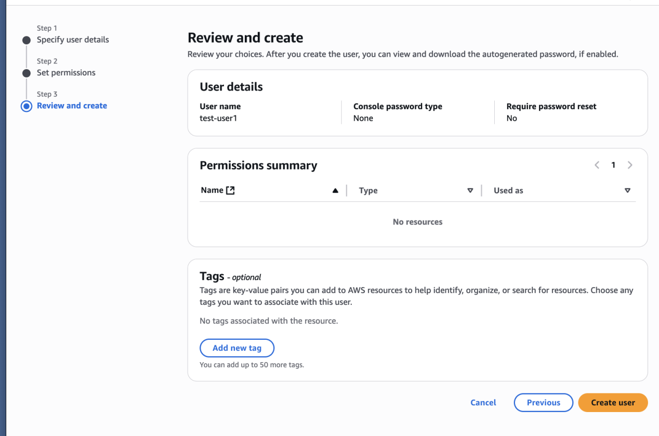

* go to the user and click add permmisins and click the ec2 full acces and s3 full acces then click on add permmisions

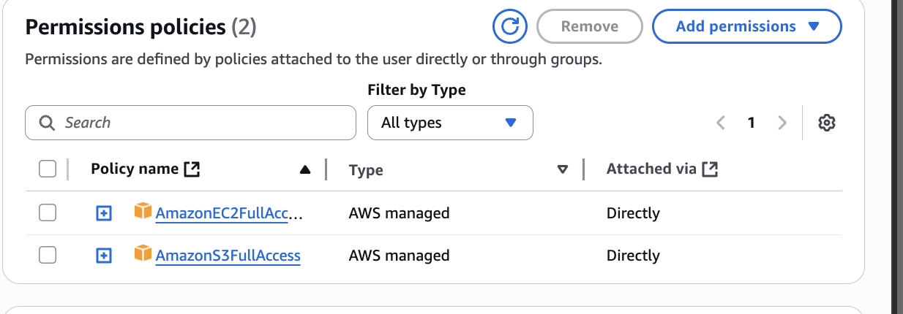

* then verify in the user you have crated that the acces is granted or not

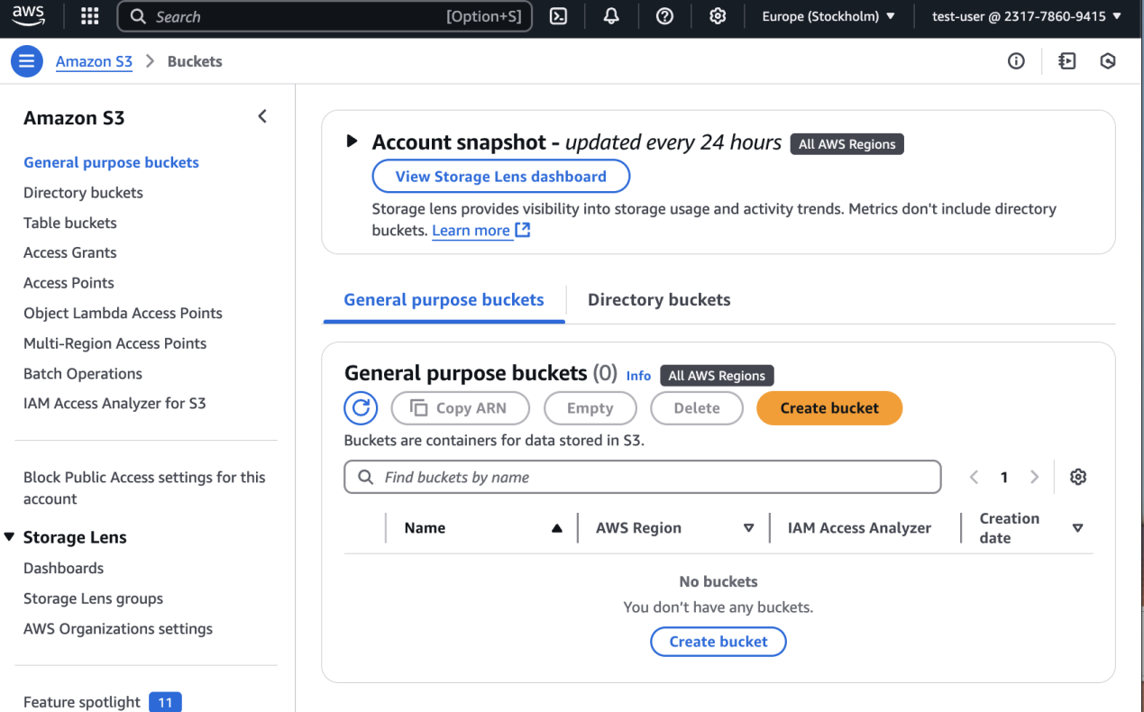

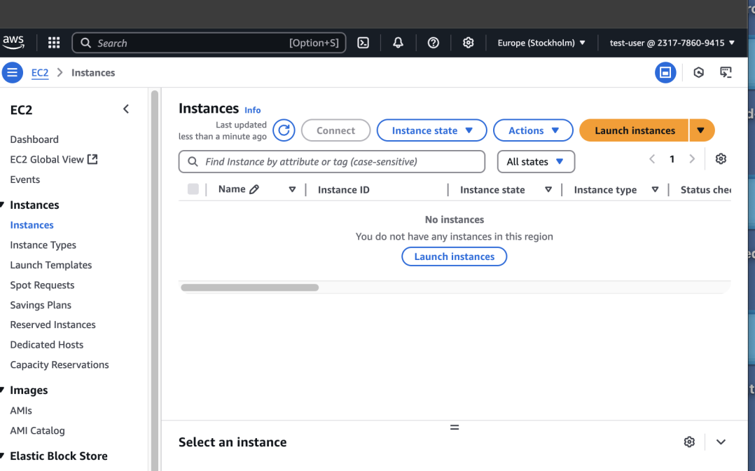

1. Create one Group in IAM and Assign Read access for ec2.

* first you need to create user group
* after creating user group then attache the user
* in the usergroup go permmisions and click on add policy
* then select amazonec2readonly policy and then create the group
* verify that the ec2 is access or not in the test user

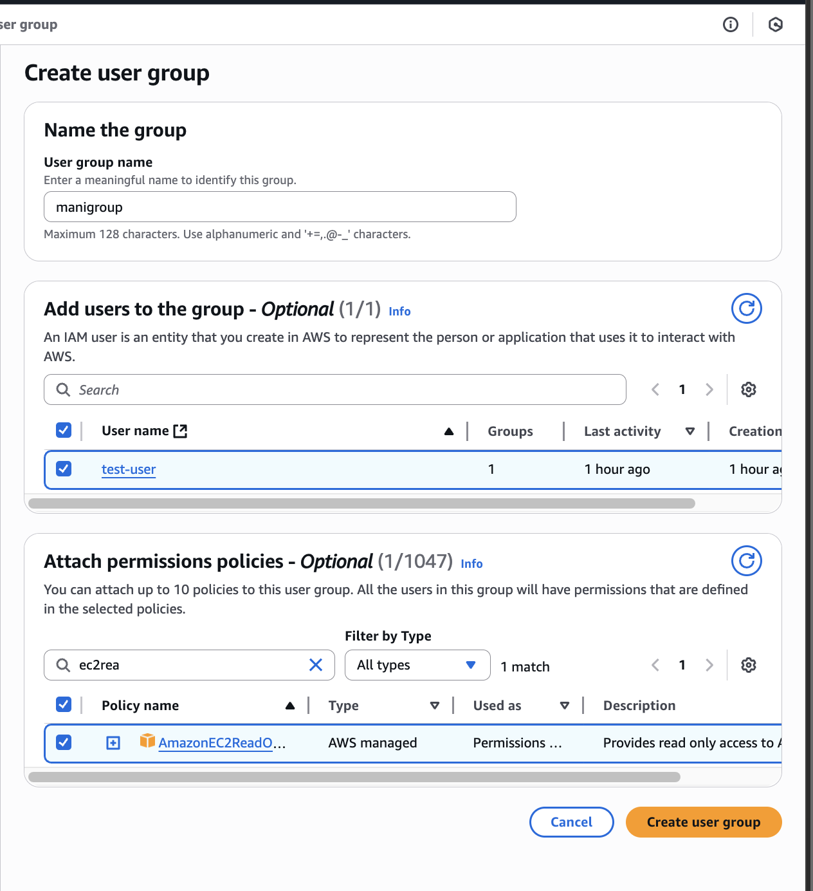

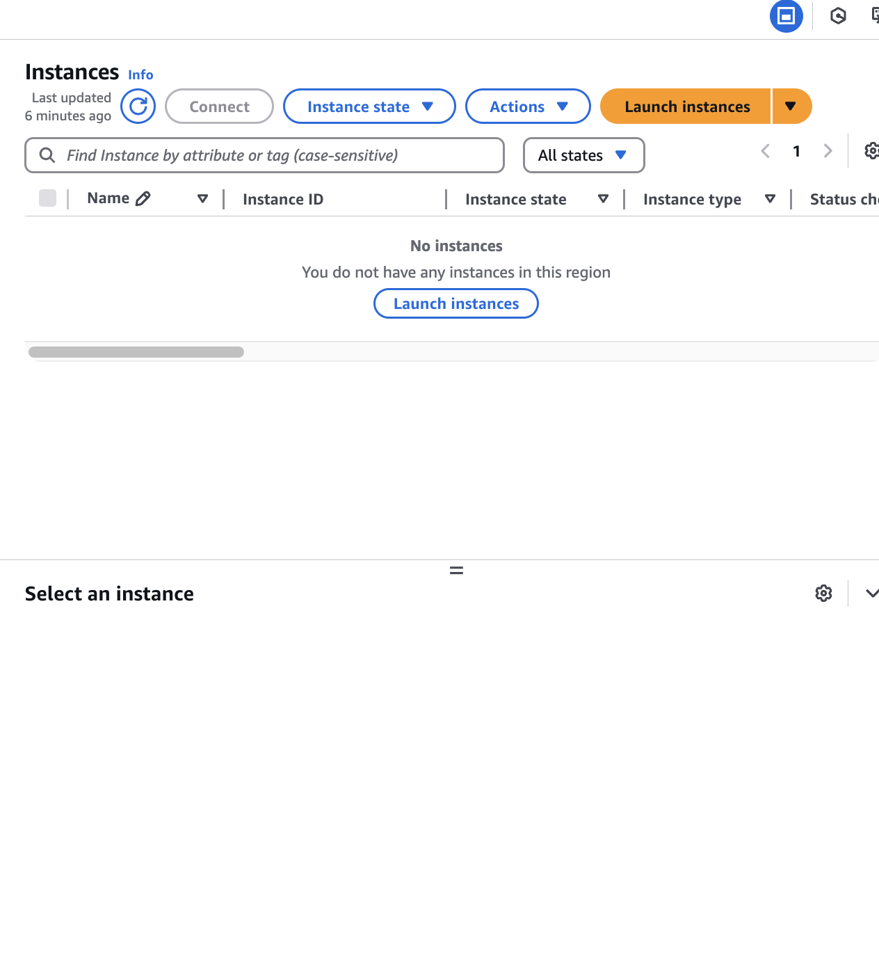

1. Create a new user with name Devops and add to the group created in task2.

* go to user and give the name Devops and click on next
* then in user groups you will see the preveous create user group >>select that >>click on next >>cilck on create user
* go to user group and check the user is added or not

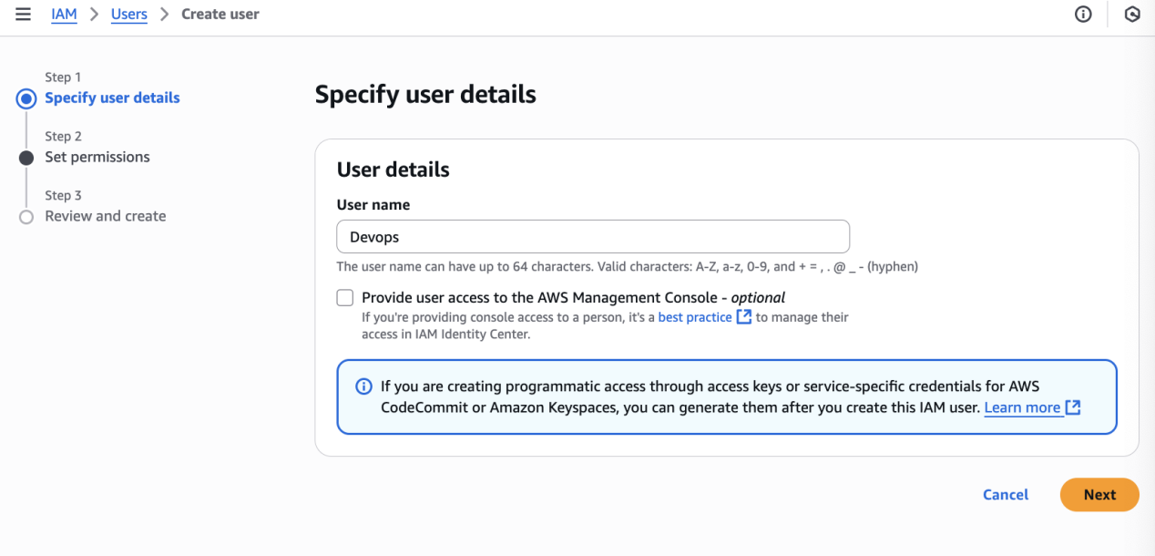

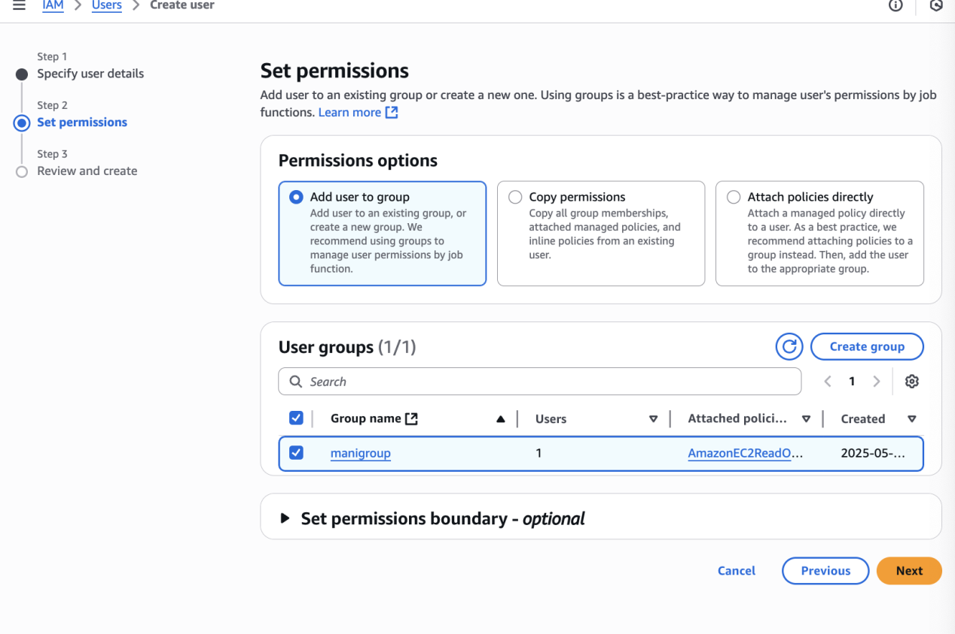

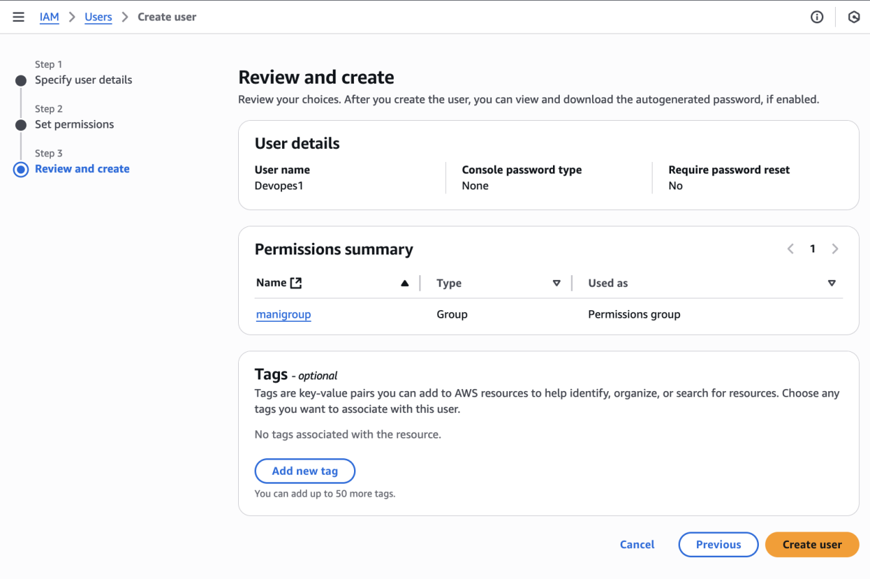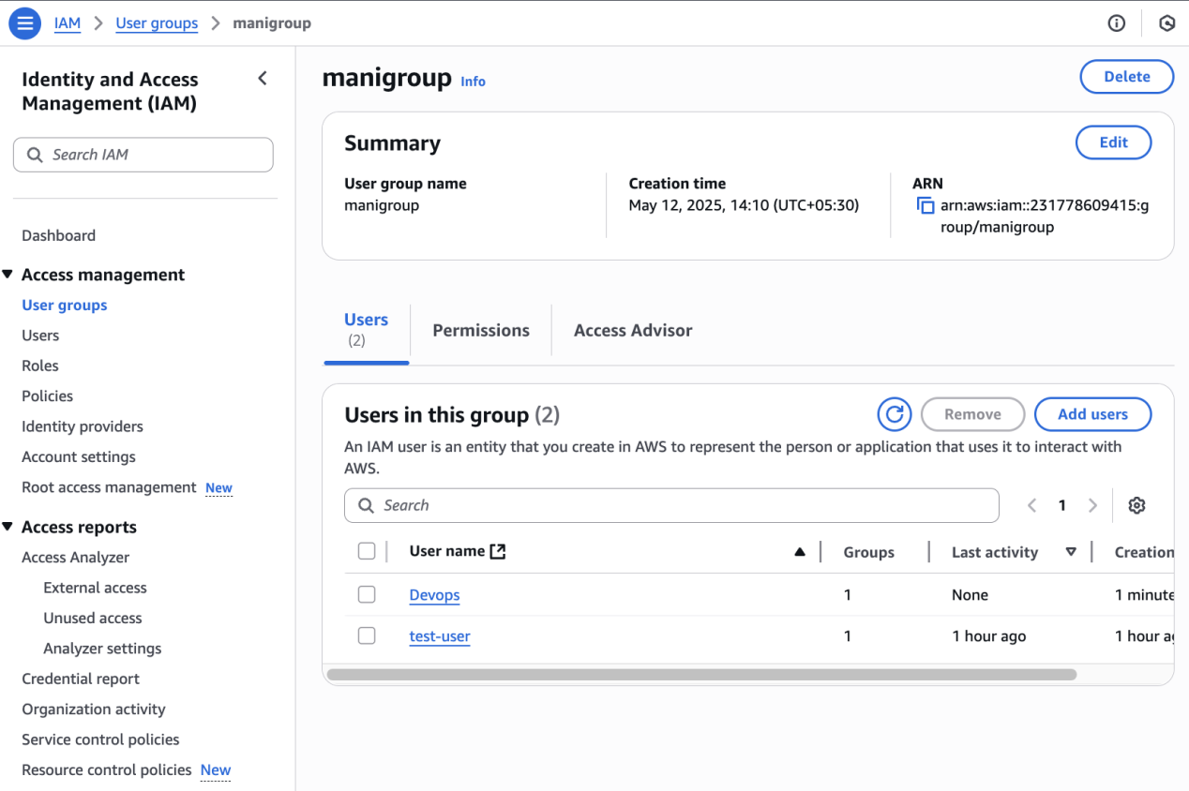

1. Write a bash script to create a IAM user with VPC full access.

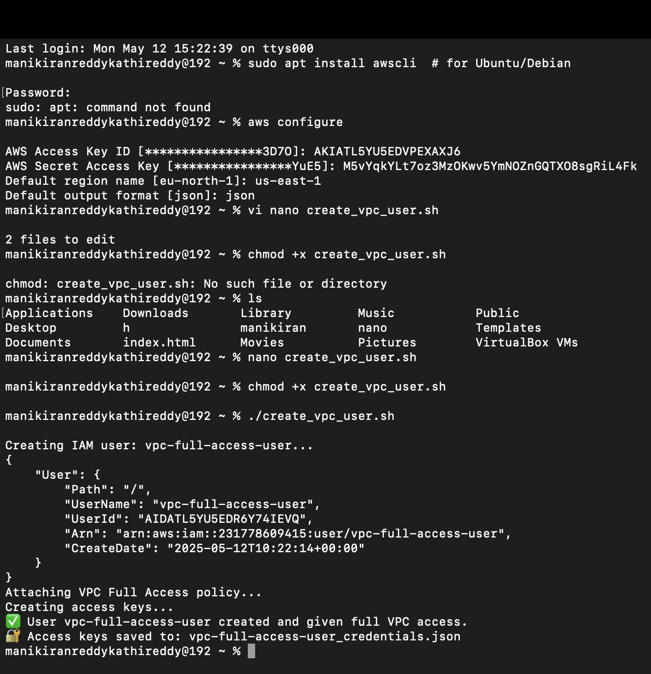

#!/bin/bash

USER_NAME="vpc-full-access-user"

POLICY_ARN="arn:aws:iam::aws:policy/AmazonVPCFullAccess"

echo "Creating IAM user: $USER_NAME..."

aws iam create-user --user-name "$USER_NAME"

echo "Attaching VPC Full Access policy..."

aws iam attach-user-policy --user-name "$USER_NAME" --policy-arn "$POLICY_ARN"

echo "Creating access keys..."

aws iam create-access-key --user-name "$USER_NAME" > "${USER_NAME}_credentials.json"

echo "✅ User $USER_NAME created and given full VPC access."

echo "🔐 Access keys saved to: ${USER_NAME}_credentials.json"

1. Create a IAM policy to access ec2 for a specific user in specific regions only.

* go to the polocys and select EC2 and slect Describe regions
* then in the request conditions give the regions and click on create policy
* then attach that policy to the user and then verify it is working or not

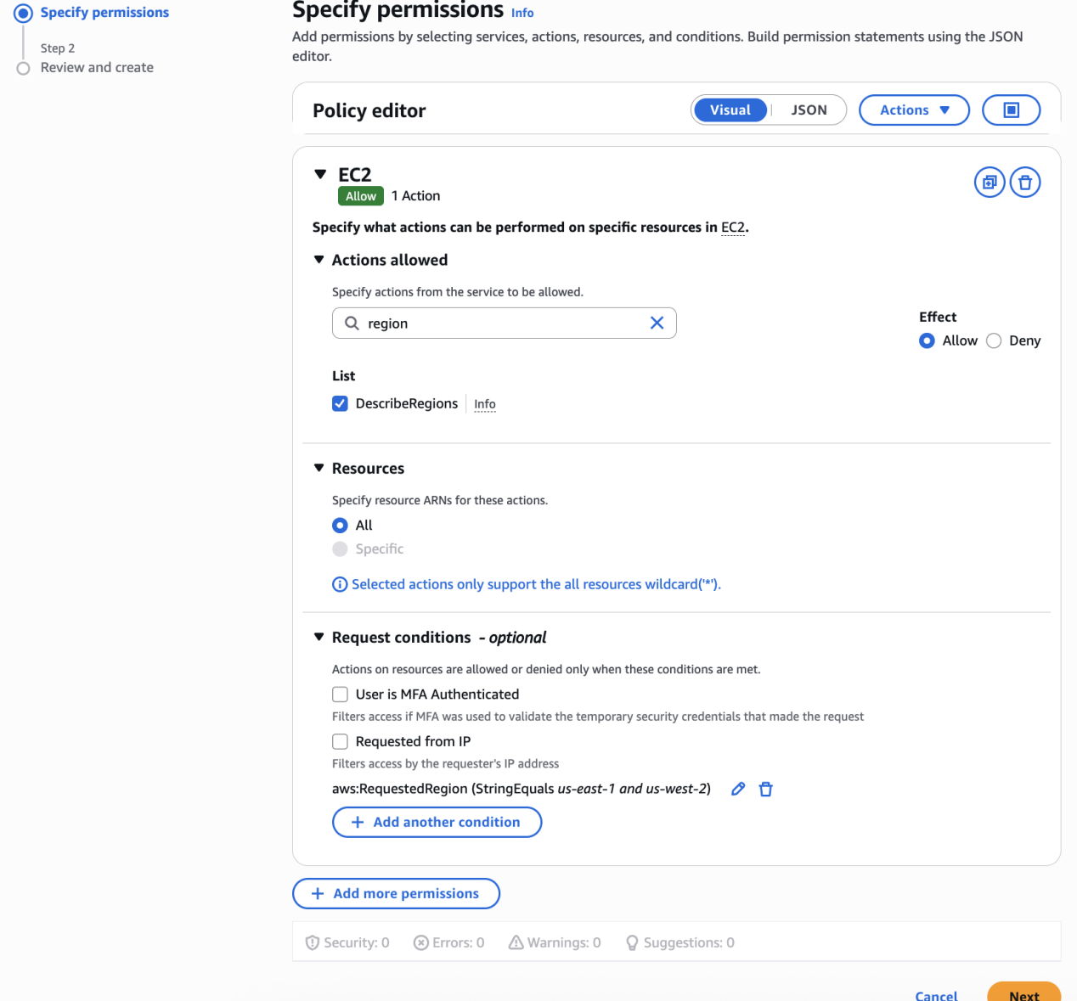

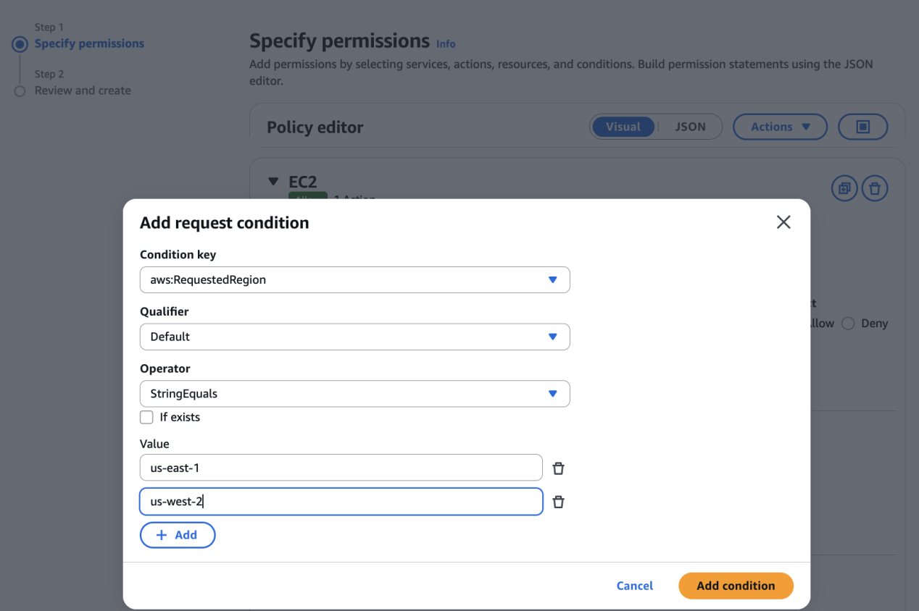

6) We have two accounts Account A and Account B, Account A user should access s3 bucket in Account B.

(Collaborate with team member and execute this.Mostly asked in every interview)

* in **account a**

**s3 bucket policy :**

in policy attach s3 bucket arn and user arn

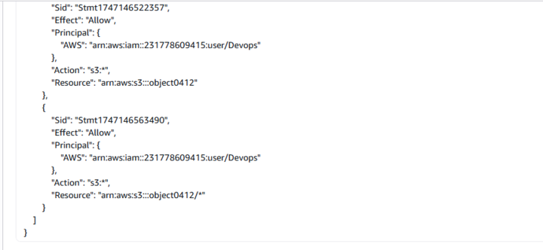

* in **account b** users data

**bucket policu edit :**

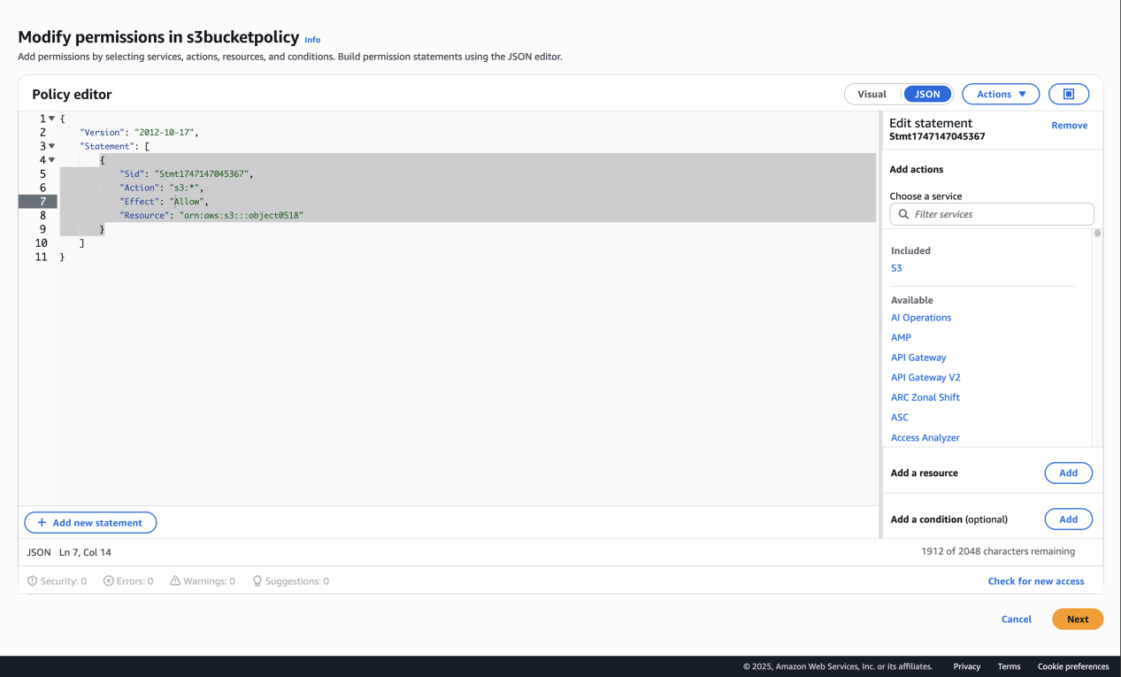

* to verify use the cammand :it will list the files

**aws s3 ls s3://object0518/ --profile Devops**

